COSC 4302-48: Introduction to Operating Systems
Homework 1
Due: 10:00am, Sept. 21, 2018 (Friday)

Name: ______________________

LUID: ______________________

Date: ______________________

(20 points) 1. We discussed the following example solution in our class. Is it possible to have three simultaneous processes in execution? Please give one example to support your answer.

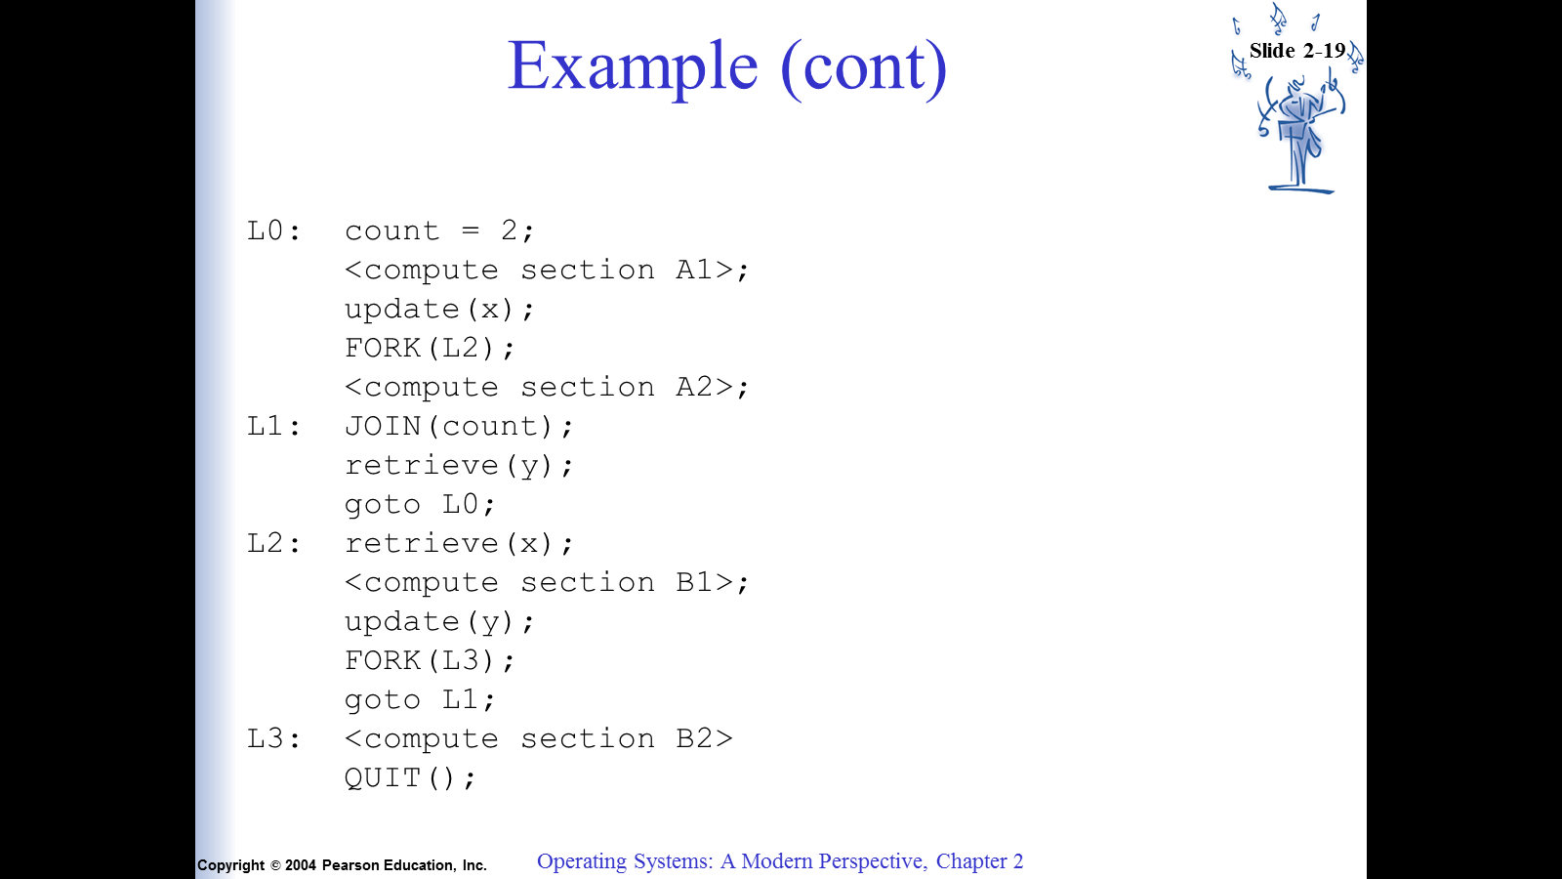

(20 points) 2. Textbook: p. 74 -> question 3: Write a UNIX program that creates a child process….

(60 points) 3. Please read Lab 3.1 – Observing OS behavior on p. 112 of the textbook. This will give you the necessary background on /proc file system of Linux.

Implement this program (open, read, and close files):
- pick up any running process, obtain its PID, and report its “cmdline”;
- report /proc/modules

Note:

1. Please type all your homework.

2. Please program on Unix/Linux platforms. You may use either C or C++.

How to Turn In:

Softcopy: Please use BlackBoard to turn in your homework solutions. For programming questions, please do NOT use MS WORD. Please send .c files.

Class Policy:

Some programming questions are used in previous semesters. Please do NOT borrow solutions from those students who have taken this class before. We keep a database of all previous solutions.

Programming solutions will be checked carefully for plagiarism. Students who are caught copying directly will receive 0 for this assignment.

